**WINDOWS (**[**𝗦𝗤𝗟 𝗠𝗮𝘀𝘁𝗲𝗿 𝗖𝗹𝗮𝘀𝘀 For 𝗗𝗮𝘁𝗮 Engineers | 𝗗𝗮𝘁𝗮 Analyst | 𝗗𝗮𝘁𝗮 Scientist | 𝗙𝗿𝗲𝘀𝗵𝗲𝗿𝘀 in Tamil**](https://www.youtube.com/watch?v=JtaOmwnR6AM&t=13700s)**)**

Helps to avoid sub query and joins

Windows function does row based calculation across a set of row (like sum() function calculates sum of column by calculating all the records in the row)

But the main advantage is it is not affecting number of rows in the result set.

**EX:**

In below example the result set size is reduced

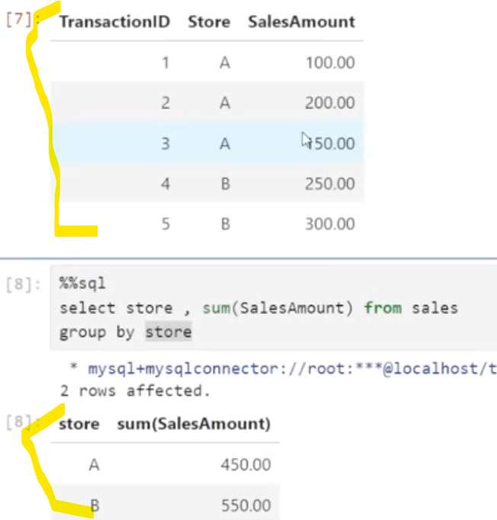

Windows function gives the below result



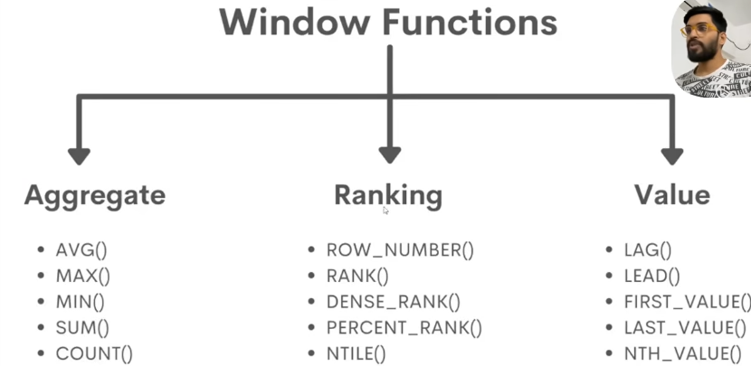

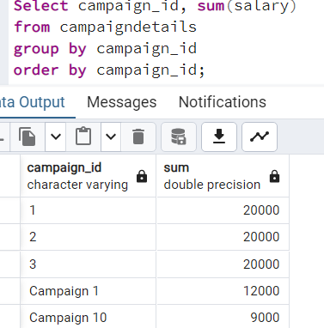

With the help of over keyword windows are created. Example given below

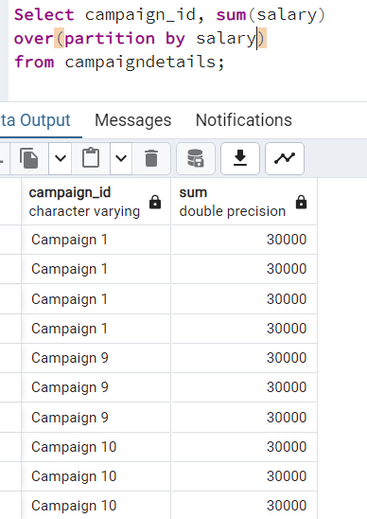

It creates a windows which can has only salary, and then the aggregate function sum will be applied on that particular window

**ROW_NUMBER:**

Used to put unique no for each row groups by some column, it is only applied on separate window.

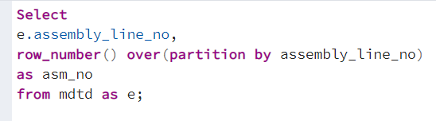

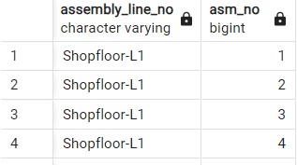

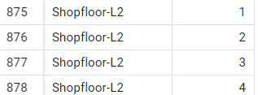

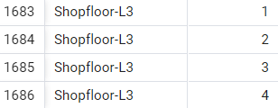

With the help of this no we can fetch the following info easily

